Johnson City Press

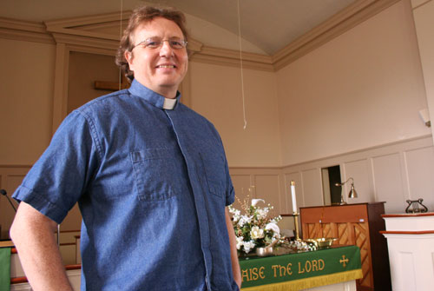
First Presbyterian Church and its pastor, John Shuck, will take part in its sixth observance of Evolution Weekend Feb. 12-13.
(Madison Mathews / Johnson City Press)

Pastor says Christians can embrace evolution
By Madison Mathews
Press Staff Writer
mmathews@johnsoncitypress.com
ELIZABETHTON — Can a person of faith also believe in science?
For the Rev. John Shuck of First Presbyterian Church, 119 W. F St., the answer is simple. Shuck believes it’s important to “keep science, science and religion, religion.”
“From my point of view, it’s also about having a faith that is more expansive than what we might think. When I look at the Bible and read Genesis, I don’t see a science book or even a history book, I see more of a story to tell us about the human condition,” he said. “I think there’s a misreading of the Bible to read it literally or as a science book or as to thinking that the folks who were writing have the same perspectives that we do today.”
While the issue of creation versus evolution can be a controversial topic for some Christians, Shuck said it’s important for believers who do affirm science to stand up and admit it’s OK to be a Christian and embrace the theory of evolution.
That’s why First Presbyterian will host Evolution Weekend Feb. 12-13. For six years, the church has participated in the event with hundreds of congregations across the country.
Evolution Weekend is sponsored by the Clergy Letter Project, which was started by Dr. Michael Zimmerman, a biology professor at Butler University in Indiana, in 2004. The Clergy Letter Project was initiated in order to raise awareness that people of faith can also believe in science, including evolution, and to establish a better understanding of the relationship between religion and science.
“ ... Christian clergy from many different traditions believe that the timeless truths of the Bible and the discoveries of modern science may comfortably coexist,” the letter reads.
Shuck is one of more than 12,000 clergy to sign the letter since the project began.
Since first joining in celebrating evolution in 2006, Shuck said, Evolution Weekend has become one of the church’s biggest events. That came as quite the surprise to a minister who came to the South from Montana.
“It’s been a little bit of a surprise. There’s just a lot of religion here, and so I was kind of interested in that it is such a big issue,” he said. “I don’t think that it’s going to be ultimately polarizing. I think that the conversation is good to have.”
Shuck acknowledges the conflict Christians have with embracing something like evolution, but he believes the Christians who attempt to refute the theory using scripture are treating the Bible as something it was never intended to be.
“I think it’s important from a science point of view to continue to give our children the best education that they can. It’s because of what we know through science and evolutionary history that we’re able to do a lot of things with biology and medicines and all kinds of things. I think it’s just important to know for the sake of knowing true things,” he said.
Questioning one’s faith is something that’s healthy, according to Shuck, especially when it comes to issues that aren’t necessarily so black and white.
“People have a spiritual struggle. For me, I find people who see that Christianity is either, ‘You’ve got to believe the whole deal ... or you have to be an atheist.’ I think that’s often the choice they have to make,” he said.
In Shuck’s own personal experience, it’s that kind of thinking that ultimately turns people away from faith.
Being a Christian and believing in evolution should strengthen one’s faith, Shuck said.
“It’s an expansion. God becomes more mysterious, less tamed, less small,” he said. “I think it’s a miracle just watching grass and bugs and thinking about how huge the universe is and the very fact that I’m alive at all. To me, God is that wow, that awe, that sense of sacredness.”
Evolution Weekend is taking place during the same weekend of the Origins Conference in Johnson City. More than 100 churches have partnered to host the conference, which offers a full week of seminars with speakers from the creationist movement.
Shuck said he thinks it’s great to have both sides of the argument taking place at the same time because it will help facilitate discussion surrounding religion and science.
He hopes Evolution Weekend will help those struggling with these issues realize it’s OK to believe in both.
“I would offer this as an invitation to people who’ve thought 'I have to be one or the other' or 'I have to be an atheist' because all Christians are this way. There’s a broad middle ground — one that respects our search, one that respects science and one that respects the tradition of our faith,” he said.
The community is invited to participate in four activities as part of Evolution Weekend, including the Friends of Roan Mountain Naturalist Rally, an adult forum on the evolution of the human brain, a church service led by Shuck and a field trip to the Gray Fossil Site and Museum.
For more information on Evolution Weekend, including times and a full schedule, call 543-773 or visit www.fpcelizabethton.org.

